Organisation 1 & 2 project proposals



Student Name: Angelique Fernandez
Student Number: ST10504943
Module Name: Web Development (Introduction)
Module Code: WEDE5020

1.Endless Empathy

- Organisation Name: Endless Empathy.
- Category: Non-Profit Organisation.

What is the organisation about?
- What it does: A community-focused non-profit organization, with the motto “Serving with Heart and Purpose.” The initiative is dedicated to providing support, care, and outreach to people in need in the community. Aiming to expand as time goes on.
- Services Offered: Community support programs and volunteer-led social services with hopes to expand their outreach.
- Target Audience: Local community members, people in need of support, volunteers, and doners looking to help.

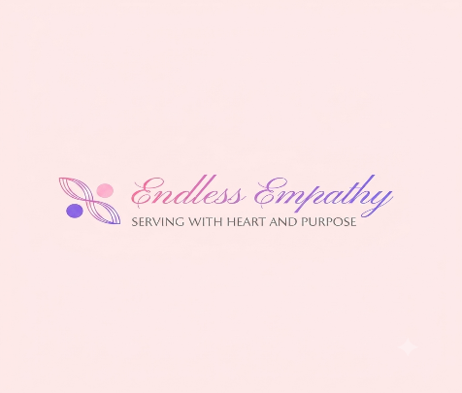
Website status:
- Website?: They do not currently have a website.
- Website Link: N/A

Motivation:
- Why Selected?: Endless Empathy currently lacks a digital platform. Making it difficult to reach more people in need, volunteers, or Donors.
- Potential Impact: Creating a dedicated website will improve community outreach. It will allow more doners to see what the organisation does and will open doors for more donations as well as, give volunteers and individuals in need access to the website and contact information. Enabling them to reach out to the organisation.

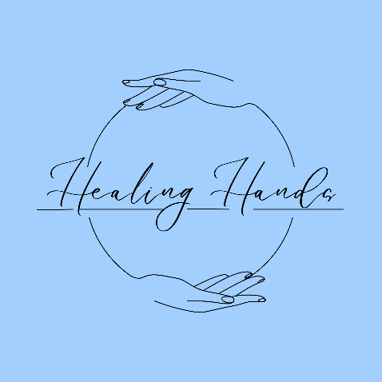
2. Healing Hands

- Organisation Name: Healing Hands.
- Category: Non-Profit Organisation.

What is the organisation about?
- What it does: Provides professional treatments focusing on stress relief, Muscle recovery, and holistic physical wellness.
- Services Offered: Deep Tissue massage, Swedish massage, hot stone massage, manicure, pedicure, and sports massage.
- Target Audience: Clients seeking relief and relaxation. Clients in need of relief from everyday street and chronic pain. Perfect for athletes, working professionals, elderly, or clients needing regular self-care treatment.

Website status:
- Website?: They do not currently have a website.
- Website Link: N/A

Motivation:
- Why Selected?: Healing hands operates primarily vis phone calls or walk-ins. Lacing a online system to aid in bookings, inquires, and displaying services.
- Potential Impact: A custom website will improve online bookings, and the digital service menu will streamline scheduling, reduce missed appointments, and attract new clients looking for local massage services online.

